IF function
The IF function is one of the most popular functions in Excel, and it allows you to make logical comparisons between a value and what you expect.
So an IF statement can have two results. The first result is if your comparison is True, the second if your comparison is False.
For example, =IF(C2=”Yes”,1,2) says IF(C2 = Yes, then return a 1, otherwise return a 2).

IFS
Use the IFS function to check whether one or more conditions are met and returns a value that corresponds to the first TRUE condition.
- Select the cell you want to create a IFS function from.
- Type =IFS(.
- Create the first condition.
- Add the other conditions.
- Press Enter.

Apply the IFS formula to the column
- Type $ to add an absolute reference to an existing IFS formula.
- Drag to bring this formula down in a column.

SUMIF
Use the SUMIF function to sum the values in a range that meet criteria that you specify.
- Select a cell where you want to write the formula.
- Type =SUMIF(.
- Select the range of cells that you want to evaluate by the criteria.
- Type a comma and enter the criteria.
- Type a comma and select the SUM range. It'll be the same size and shape as the original range you selected.
- Press Enter.

SUMIFS

The SUMIFS function is a premade function in Excel, which calculates the sum of a range based on one or more true or false condition. It is typed =SUMIFS : =SUMIFS(sum_range, criteria_range1, criteria1, [criteria_range2, criteria2] ...)

Use SUMIFS to test multiple conditions and return a value based on those conditions. For example, you could use SUMIFS to sum the number of a products sold by a certain salesperson.
Now assemble the above parameters, and you will get the following SUMIFS formula:
=SUMIFS(C2:C9, A2:A9, "apples", B2:B9, "Pete")
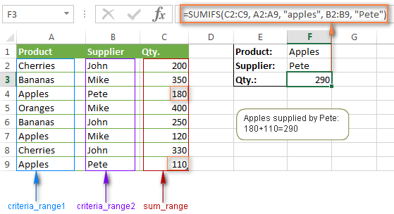

Syntax
SUMIFS(sum_range, criteria_range1, criteria1, [criteria_range2, criteria2], ...)
- =SUMIFS(A3:A10,B3:B:10,B13,C3:C10,A13)
- Sum the values in the cell A3 to A10 for the rows where the value in B3 to B10 is B13, and the value in C3 to C10 is A13.

Steps
- Select a cell.
- Type =SUMIFS, and a left parenthesis (.
- Select the sum range, and type a comma.
- Select the first criteria range, and type a comma.
- Select the criteria, and type a comma.
- Select the second criteria range, and type a comma.
- Select the criteria, and type a comma.
- Add a right parenthesis ) and select Enter.

COUNTIF function
Use COUNTIF, one of the statistical functions, to count the number of cells that meet a criterion; for example, to count the number of times a particular city appears in a customer list.
How to use the =COUNTIF function:
- Select a cell
- Type =COUNTIF
- Double click the COUNTIF command
- Select a range
- Type ,
- Select a cell (the criteria, the value that you want to count)
- Hit enter

COUNTIFS FUNCTION
The COUNTIFS function is a premade function in Excel, which counts cells in a range based on one or more true or false condition.
Example COUNTIFS function, step by step:
- Select the cell G3
- Type =COUNTIFS
- Double click the COUNTIFS command
- Specify the range for the type B2:B759 (the Type 1 values)
- Type ,
- Specify the criteria (the cell E3, which has the value "Water")
- Type ,
- Specify the range for the second conditionC2:C759 (the Generation values)
- Type ,
- Specify the criteria (the cell F3, which has the value "1")
- Hit enter

Examples
The conditions are that the type is "Water" and Generation is 1.
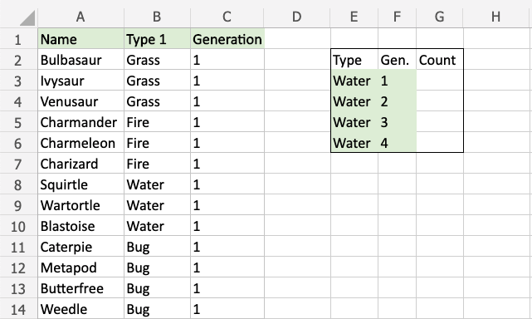

VLOOKUP
Use VLOOKUP when you need to find things in a table or range by row.
- Select a cell.
- Type =VLOOKUP( and then select the value to lookup.
- Type a comma (,) and select the range or table to look for the value.
- Type a comma (,) and the number of the column where the lookup value is located.
- Type ,FALSE) to find an exact match.
- Press Enter.
The formula for the video example is as follows:
=VLOOKUP(A7, A2:B5, 2, FALSE).
In its simplest form, the VLOOKUP function says:
=VLOOKUP(lookup value, range containing the lookup value, the column number in the range containing the return value, optionally specify TRUE for approximate match or FALSE for an exact match).

XLOOKUP function
Use the XLOOKUP function to find things in a table or range by row. For example, look up the price of an automotive part by the part number, or find an employee name based on their employee ID. With XLOOKUP, you can look in one column for a search term and return a result from the same row in another column, regardless of which side the return column is on.

Syntax
The XLOOKUP function searches a range or an array, and then returns the item corresponding to the first match it finds. If no match exists, then XLOOKUP can return the closest (approximate) match.
=XLOOKUP(lookup_value, lookup_array, return_array, [if_not_found], [match_mode], [search_mode])
Argument | Description
lookup_value  Required* | The value to search for  *If omitted, XLOOKUP returns blank cells it finds in lookup_array.
lookup_array  Required | The array or range to search
return_array  Required | The array or range to return
[if_not_found]  Optional | Where a valid match is not found, return the [if_not_found] text you supply.  If a valid match is not found, and [if_not_found] is missing, #N/A is returned.
[match_mode]  Optional | Specify the match type:  0 - Exact match. If none found, return #N/A. This is the default.  -1 - Exact match. If none found, return the next smaller item.  1 - Exact match. If none found, return the next larger item.  2 - A wildcard match where *, ?, and ~ have special meaning.
[search_mode]  Optional | Specify the search mode to use:  1 - Perform a search starting at the first item. This is the default.  -1 - Perform a reverse search starting at the last item.  2 - Perform a binary search that relies on lookup_array being sorted in ascending order. If not sorted, invalid results will be returned.  -2 - Perform a binary search that relies on lookup_array being sorted in descending order. If not sorted, invalid results will be returned.

Examples
Example 1 uses XLOOKUP to look up a country name in a range, and then return its telephone country code. It includes the lookup_value (cell F2), lookup_array (range B2:B11), and return_array (range D2:D11) arguments. It doesn't include the match_mode argument, as XLOOKUP produces an exact match by default.
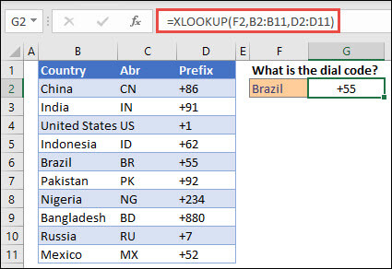
Note: XLOOKUP uses a lookup array and a return array, whereas VLOOKUP uses a single table array followed by a column index number. The equivalent VLOOKUP formula in this case would be: =VLOOKUP(F2,B2:D11,3,FALSE)
Example 2 looks up employee information based on an employee ID number. Unlike VLOOKUP, XLOOKUP can return an array with multiple items, so a single formula can return both employee name and department from cells C5:D14.
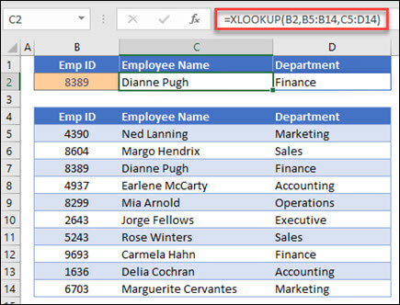
———————————————————————————
Example 3 adds an if_not_found argument to the preceding example.
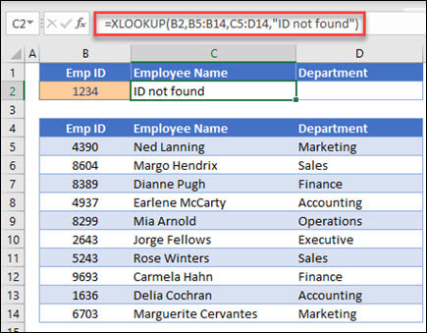
———————————————————————————
Example 4 looks in column C for the personal income entered in cell E2, and finds a matching tax rate in column B. It sets the if_not_found argument to return 0 (zero) if nothing is found. The match_mode argument is set to 1, which means the function will look for an exact match, and if it can't find one, it returns the next larger item. Finally, the search_mode argument is set to 1, which means the function will search from the first item to the last.
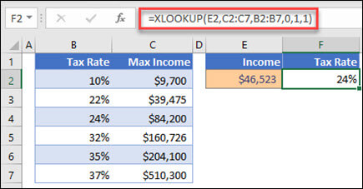
Note: XARRAY's lookup_array column is to the right of the return_array column, whereas VLOOKUP can only look from left-to-right.
———————————————————————————
Example 5 uses a nested XLOOKUP function to perform both a vertical and horizontal match. It first looks for Gross Profit in column B, then looks for Qtr1 in the top row of the table (range C5:F5), and finally returns the value at the intersection of the two. This is similar to using the INDEX and MATCH functions together.
Tip: You can also use XLOOKUP to replace the HLOOKUP function.
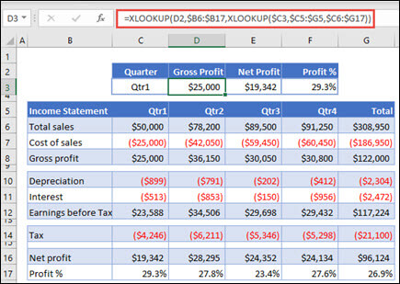
Note: The formula in cells D3:F3 is: =XLOOKUP(D2,$B6:$B17,XLOOKUP($C3,$C5:$G5,$C6:$G17)).
———————————————————————————
Example 6 uses the SUM function, and two nested XLOOKUP functions, to sum all the values between two ranges. In this case, we want to sum the values for grapes, bananas, and include pears, which are between the two.
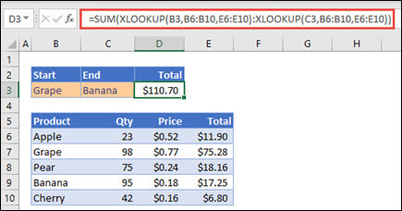
The formula in cell E3 is: =SUM(XLOOKUP(B3,B6:B10,E6:E10):XLOOKUP(C3,B6:B10,E6:E10))
How does it work? XLOOKUP returns a range, so when it calculates, the formula ends up looking like this: =SUM($E$7:$E$9). You can see how this works on your own by selecting a cell with an XLOOKUP formula similar to this one, then select Formulas > Formula Auditing > Evaluate Formula, and then select Evaluate to step through the calculation.

